Welcome to MS Azure

How to publish asp.net project to MS Azure Service

**ASP.NET Core preview releases with Azure App Service**

ASP.NET Core preview releases aren't deployed to Azure App Service by default. To host an app that uses an ASP.NET Core preview release, see

[**Deploy ASP.NET Core preview release to Azure App Service**](https://docs.microsoft.com/en-us/aspnet/core/host-and-deploy/azure-apps/?view=aspnetcore-5.0#deploy-aspnet-core-preview-release-to-azure-app-service). <https://docs.microsoft.com/en-us/aspnet/core/tutorials/publish-to-azure-webapp-using-vs?view=aspnetcore-5.0>

<https://docs.microsoft.com/en-us/visualstudio/deployment/quickstart-deploy-to-azure?view=vs-2019>

|  |  |
| --- | --- |
|  |  |

# Deploy the app to Azure

1. Right-click on the project in Solution Explorer and select Publish....



1. In the Publish dialog:

Select Azure.

Select Next.

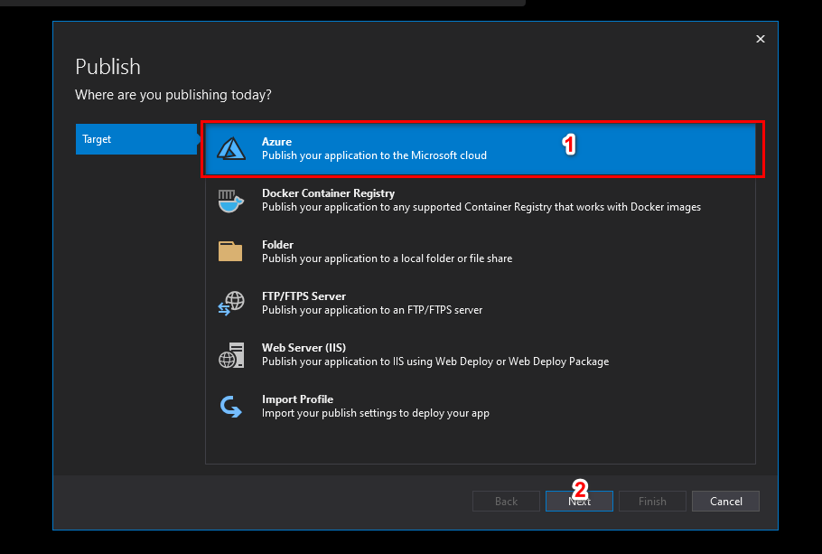

1. In the Publish dialog:

Select Azure App Service (Windows).

Select Next.

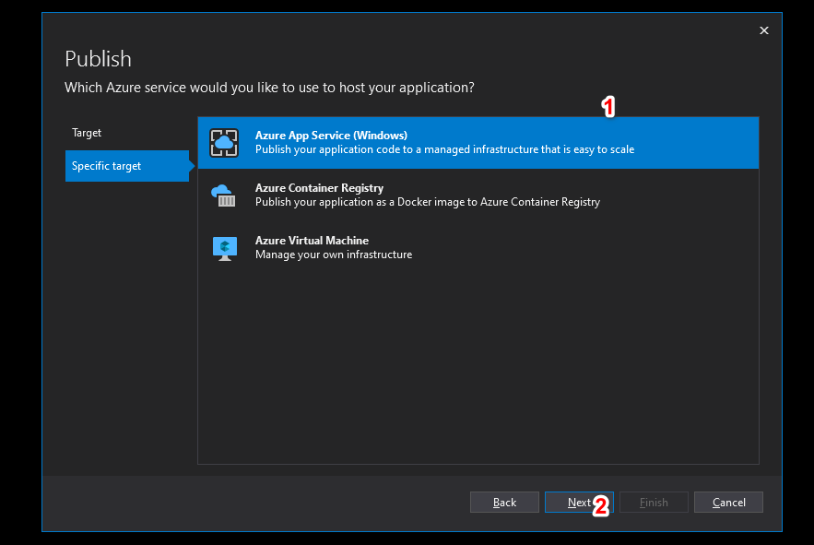

<https://docs.microsoft.com/en-us/aspnet/core/tutorials/publish-to-azure-webapp-using-vs?view=aspnetcore-5.0>

1. Sign in with your Azure account, if necessary. Select Create a new Azure App Service...
2. Then In the Create Azure App Service (Windows) dialog, the App Name, Resource Group, and App Service Plan entry fields are populated. You can keep these names or change them. When ready, select Create.
3. In the Publish dialog, the newly created instance has been automatically selected. When ready, select Finish.
4. Select Publish. Visual Studio deploys the app to your Azure App Service, and the web app loads in your browser. The project properties Publish pane shows the site URL and other details.